## **Al-Nahrain University**

## **College of information engineering**

## **Networks department**

Assignment Three

Tamara Majid

Third stage

Procedure

1-I installed Vm ware workstation

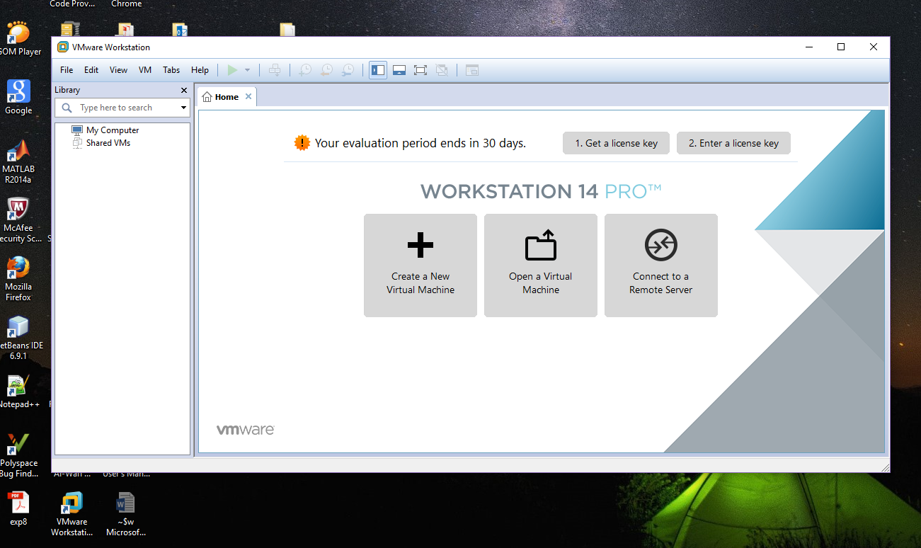

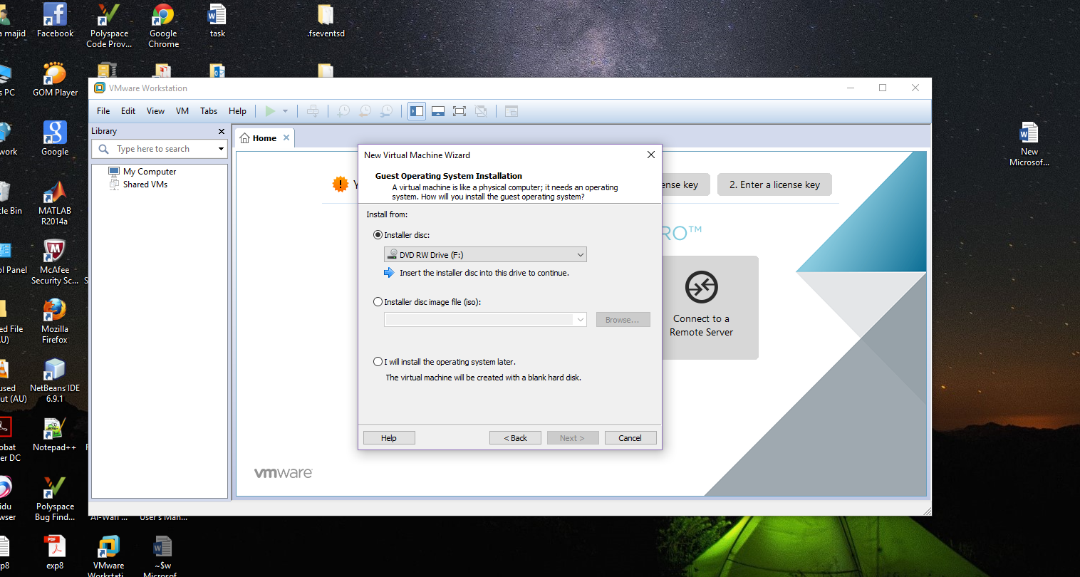

2-I selected linux operating system

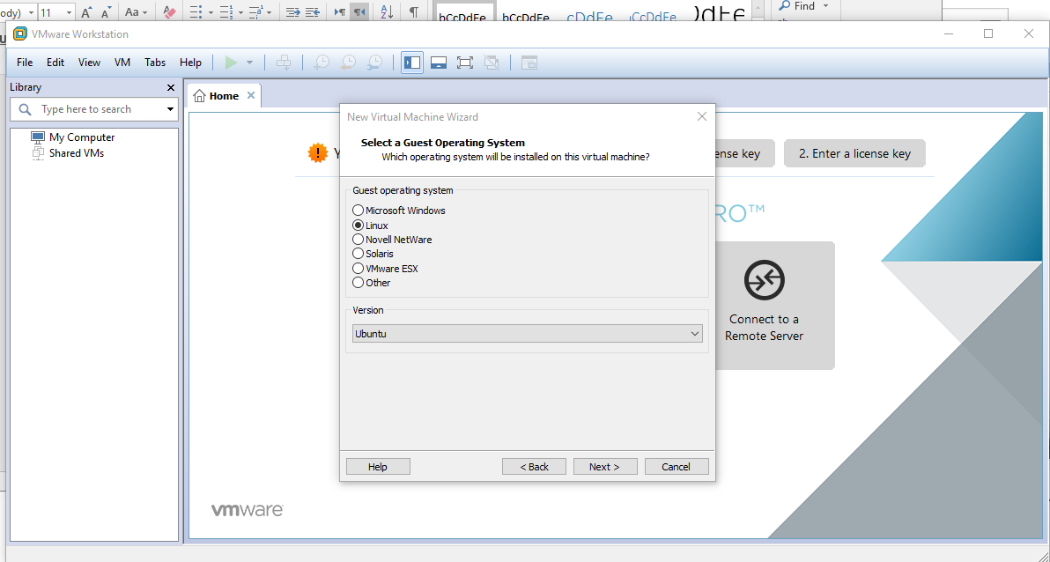

3-- I created two virtual machines

First machine :

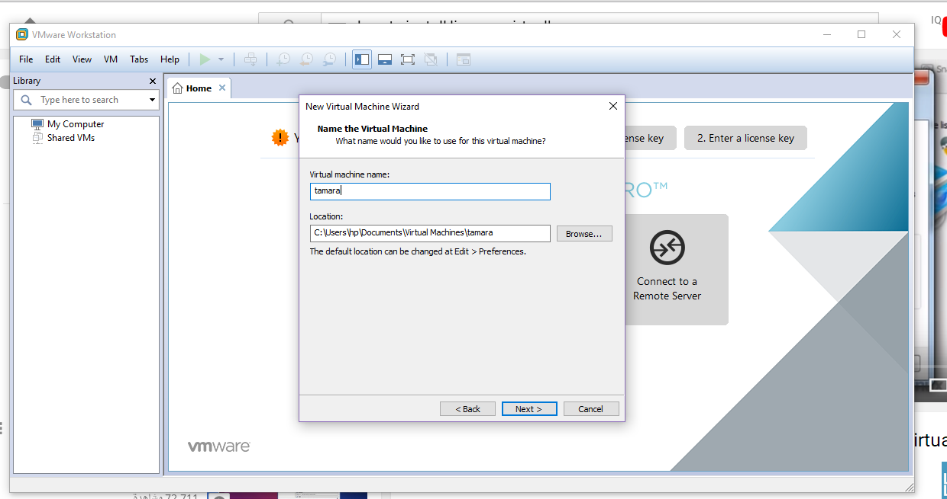

The capacity is : 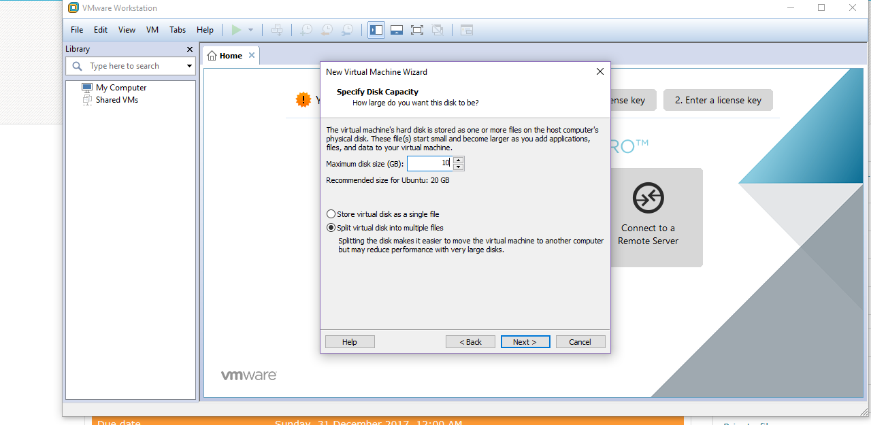

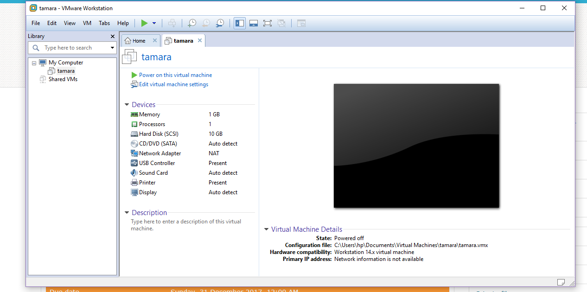

Second machine:

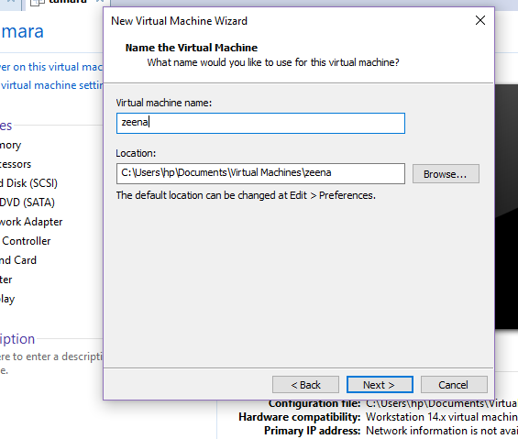

:

With the same Size of capacity

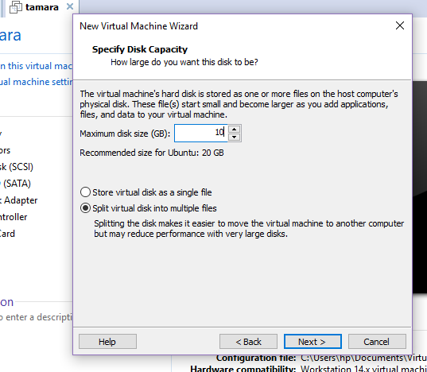

I tried to download Ubuntu many times but in every time failed to download it in my computer I searched and tried to solve problem but I didn’t know the reason.